Progress in Demonstration Models Component
Canada-Russia Disability Program, Mental Health Stream
Mid-Term Summary, May 31, 2005

Central Russia Regions
Moscow: MRIP and Dispensary # 14
The Moscow region is a complex context for model development, for reasons of population size, the complexity of service arrangements, rigid administrative governance system, and traditional roles that lead organizations have both locally and nationally. In this context, the role of the MRIP is both one of providing support to centres across Russia, and exercising a certain amount of leadership in developing demonstration models locally. With respect to local innovative elements of community-oriented services, the Institute has three (3) initiatives it is directly involved with: an Early Episode Clinic, psychosocial programs developed at the Dispensary # 14, and support of New Choices.
- Russia’s first Early Episode Treatment Day Clinic was developed at the Institute, and has become a model for others. This model provides multidisciplinary, team-based early intervention to mostly young adults experiencing their first psychotic episode, without hospitalization, while they live in the community (as opposed to the traditional long-term hospital treatment). This includes active involvement of families, facilitating lasting community supports and inclusion, and preventing the loss of social connections due to psychosis. The movement has spread across Russia, with over 20 centres developed in different regions. Current priority is to enhance the quality of such clinics, and promote adopting of consistent standards of practice, performance evaluation mechanisms. Evaluation tools are being developed and tested, with initial performance evaluation data available.

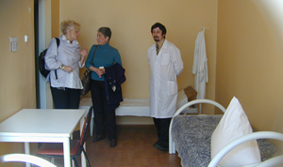
First Psychotic Episode Clinic at the Moscow Research Institute of Psychiatry. The clinic works as a Day Hospital and provides an alternative to hospitalization, and is based on the psychosocial rehabilitation model. This Clinic was the first of its kind in Russia, and was an analogue Calgary clinic, one of the very few clinics of its kind in the world. Since the UCGF projects were completed, the First Episode treatment model spread to a growing number of other regions throughout Russia.

- A number of innovative approaches are being tested at Dispensary # 14:
- Psychosocial treatment programs for persons with the history of long-term and frequent hospitalizations, including group work, social skills training, continuity of in- and out-patient services, and use of the team approach.
- A partnership has been established between the Dispensary and Moscow Regional Hospital # 10 to prevent repeated re-hospitalization of people with severe and chronic psychiatric illness (so called “revolving doors” phenomena). This partnership is developing and testing the effectiveness of providing continuity of services from hospital treatment / rehabilitation to outpatient follow-up and community living. Evaluation tools are being developed and tested for this model, with initial performance evaluation data available.
- There has been discussion on use of the Dispensary as a site for practicum for SW students.
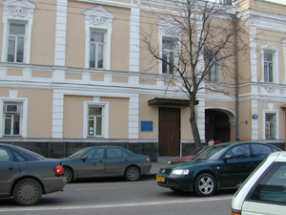
Moscow Dispensary # 14 (front entrance)

- Support is given to the All-Russia Society New Choices in promoting and supporting its independence and self-sufficiency.

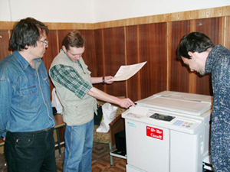

Employment project for young persons with schizophrenia was initiated in 2002 by the Moscow organization New Choices. The workshop has become self-sustainable and continues to involve young people in job training and employment activities
Moscow Regional Hospital # 10
This hospital is probably the first in Russia to re-orient an entire institution for people with severe and chronic mental illness to be a rehabilitation centre. Leadership has been provided by graduates of our Community of Learners with the support of the administration. Key activities underway include the following.
- Shifting focus from long-term treatment of persons with chronic psychiatric illness towards the major objective of rehabilitation and discharge preparation, with community living skill training. The emphasis is on preventing repeated re-hospitalization. This includes the following:
- An improved therapeutic environment has been established throughout the hospital, with psycho-education group approach for social skill training being used with majority of in-patients. Nurses have been trained by graduates of the Canada-Russia COL train-the-trainer program, and provide the leadership. This has involved two-month training courses, with two 2-hour sessions per week, focused on psychosocial rehabilitation improvement. 25 nurses participated in the first year, and the training remained on-going in the second year.
- Psycho-education groups for relatives of in-patients have been tested in the past-six months by one of the COL graduates (1999 cohort). Since relatives live some distance from the Hospital throughout Moscow, there was initial doubt that such a group could be organized. The fact that people started to come was inspiring, and a second group is planned.
- A competition has been organized among nurses to motivate the improvement of demonstrated skills in working with consumers in a psychosocial rehabilitation context.
- A ‘Patients Council’ has been set up, and provides recommendations to staff on a variety of matters. As well, a Rehabilitation Council of staff members has been organized. A newsletter for patients is provided.
- The administrative head is pursuing the idea of developing contracts with referral sources, such as Dispensaries, which would guarantee follow-up of patients following discharge. This is modeled on the Claresholm approach (Alberta), and has been tested with Moscow Dispensary # 14 (see above). This is innovative in that Hospital #10 is meant to be an inpatient resource for dispensaries in Moscow, and formally has no outpatient responsibility.

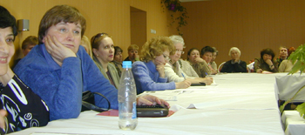
Consume/parent group meeting at the Hospital # 10, May 2005

Tambov
Tambov is rapidly pursuing a broad range of innovative services, similar to these in Omsk.
- A virtual (“functional”) Psycho-social Rehabilitation Unit has been set up to promote best practice standards and coordinate psychosocial rehabilitation work throughout the hospital. Personnel of all units are involved, using a multidisciplinary team approach. This unit is led by a COL graduate. Major objectives include discharge preparation, community living skills training, and preventing re-hospitalization by pursuing rehabilitation programming from admission on. Individualized case management approach is being used.
- The out-of-town unit located near the city, previously serving as a long-term hospital facility for persons with chronic severe mental illness, is being transformed into a rehabilitation centre with the major focus on psychosocial rehabilitation and return to the community. Treatment programs at the unit are linked to housing and job-preparation programs.

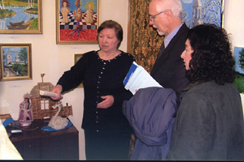
Rehabilitation activities include an art studio led by a volunteering professional artist (Tambov)

- Housing initiatives:
- Two group homes (one each for men and women) have been developed at the out-of-town unit, as a small scale pilot with small numbers of participating residents. This is a “satellite” model, with living conditions approximating those in the community, and is intended for preparing residents (who are former long-term hospital in-patients) for community living.
- A number of group home residents have graduated to independent community living, with prior establishment of a community support system. These are ‘success stories’ of stable community living arrangements achieved by people with psychiatric disabilities and a history of long-term hospitalization within the traditional system.
- It is planned to test a broader range of housing options, with different levels of independence.
- Job skill training is in place, linked to housing programs, preparing people for entry into community life. Job placements in the rural community have been arranged for some group homes’ residents.
- A Day Program with sheltered employment is being developed for people with chronic psychiatric impairment.
- A “Hospital-at-home” program has been working for more than six months. This program is designed for treatment of people with acute relapses of psychotic illness without hospitalization, by a professional outreach team at patients’ homes. Standards have been established; service is already functioning as a small pilot, with evaluation and staff training on-going
- Discussions are underway on developing two other innovative community-based services:
- An Assertive Community Treatment Team (ACT) program (not yet established).
- An Early Psychotic Episode treatment program (not yet established).
- A systematic “Family School” has been established to educate family self-help groups on a variety of issues. Participants and the programming are linked to Tambov State University.
- The hospital is in partnership with the Institute of Social Work of the Tambov State University for:
- joint consultations, seminars;
- consumer movement linked to the University (“Family School”);
- collaboration for children with emotional disorders in activities such as sports, play, crafts and others. These take place at the University campus every Saturday.
- Collaboration has been established with the Medical College for Nurses. Mental health professionals from Tambov psychiatric hospital are teaching at the College. The College curriculum now includes topics associated with psychosocial rehabilitation, and the role of the nurse in providing this service. The hospital’s administrative head has completed a research study based on practical issues of personnel training in the area of psychosocial rehabilitation in mental health (a Ph.D. dissertation has been completed).

Ryazan
Ryazan was the first region to actively develop comprehensive collaboration between mental health service and social service centres. Leadership is provided by four COL graduates from a number of consecutive cohorts. Latest developments include:
- A Psychosocial Rehabilitation Department, headed by a COL graduate, and combined across both the hospital and dispensary, has been set up to streamline movement of patients between inpatient and outpatient resources.
- A “Half-Way House” has been opened. It is located on hospital grounds, somewhat separated from other buildings, and linked to the nearby town (similar to “satellite” model). A multidisciplinary professional team is involved in supporting the residents, including a psychologist, a nurse and a social worker. Some of the residents are employed at the hospital. Performance monitoring is being conducted.
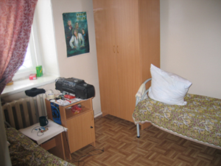
Group home – “satellite” model (Ryazan region)

- In-service training is on-going, facilitated by COL graduates: mid-level staff trained in psycho-social rehabilitation approaches work in all in-patient units and in the Dispensary catchment area.
- A targeted out-patient assistance program for persons with the history of frequent hospitalizations has been developed to prevent re-hospitalizations. On-going psycho-education support is provided to families participating in this program (multi-family psycho-education groups). This service is also provided to the families of current in-patients.
- Prior to 2003, access to social services for people with psychiatric disabilities was limited. Social service centres did not provide services to people with psychiatric impairment, as a result of misinterpretation of the current legislation. The Federal Law of August 2, 1995 N 122-FZ “Social services for seniors and people with disabilities” granted access to social services to people with psychiatric illness, with few exceptions associated with acute and dangerous conditions. However, the Law was misread, and psychiatric illness was considered a contraindication for providing social services in general. As a result of a joint advocacy initiative of mental health service providers and consumers, the Municipal Government revised their interpretation, and adopted a new instructional policy document of the municipal level titled “Standards of social services to persons with mental disorders”. This document eliminated the barrier for access to social services, and ensured the availability of the following services to consumers with psychiatric impairments:
- Close working relationships have been established with the Social Service Centre. The Centre is now providing people with severe and complicated psychiatric conditions, with instrumental support, including food, medications, clothing, etc. brought to people’s homes. In addition, consumers continue to receive professional mental health supports, coordinated with general social support. Statistical data on service use are available upon request.
- Collaboration with the city employment services in a job placement assistance program. The program provides information on available job placements, and offers free-of-charge vocational training for clients with psychiatric disabilities in educational centers of employment services. One social worker has been assigned for this service.
- Practicum placements are provided for students of the Faculty of Social Work of the Ryazan Medical College, according to the formally approved learning curriculum. The Curriculum includes obligatory practicum hours at mental health service providing organizations. One of the COL graduates who currently works at the dispensary is teaching at the College, and another two COL graduates are supervising student practicum work on an on-going basis.
- A family and consumer organization has been established several years ago, and continues to receive psycho-social education support from professionals. One of the COL graduates is providing support to club activities of consumers with chronic mental illness.

St. Petersburg
This treatment facility was traditionally intended for persons with chronic and persistent psychiatric illness whose long-term or repeated hospitalization is mainly associated with social barriers and loss of social supports. Similar to Moscow Regional Hospital # 10, the organization has shifted towards rehabilitation focus. Leadership is provided by four COL graduates from a number of consecutive cohorts, with the support of the administration.
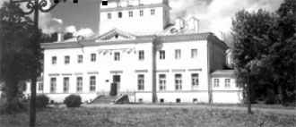

St.Petersburg Psychiatric Hospital # 1

- Psychosocial rehabilitation activities have been introduced to all hospital units. These activities included psychoeducation, skill training group programs, club work, work with families, a theater “studio”, art exhibitions, vocational programs, sports activities, and others.
- Housing program: a hostel has been developed for former in-patients in preparation for their return to the community (50 placements). The hostel is designed as a “satellite” model, with living conditions approximating those in the community, with the purpose of preparing the residents for independent living. The hostel residents are former in-patients with a history of long periods of hospital stay. The effort now is in activating movement between hospital and community. In the last three years, 160 hostel residents – former in-patients were discharged for independent living in the community.
- A multi-disciplinary team approach has been implemented in the hospital to enhance effectiveness of programs.
- An annual needs assessment (a snapshot “census”) is being conducted for all patients in the hospital, with the purpose of identifying causes of long-term hospital stay, and refining individual rehabilitation objectives for each in-patient. This assessment has resulted in the improvement of personalized rehabilitation plans for each consumer. According to the assessment, the number of in-patients with chronic psychiatric impairments decreased in average by 20%, and the average duration of hospital stay decreased by approximately 25%.
- Emphasis on training of junior and mid-level staff, with nurses doing the social skills training and other forms of psychosocial rehabilitation work. The hospital has created and is using a written course to train nurses in rehabilitation methods. A first in Russia “training school” for junior personnel (nursing assistants) has been initiated. The training program in this school emphasizes psychosocial rehabilitation approaches.

